Chris DeStefano

CIS - 3207 Sec 003

Dr. Tamer Aldwairi

11-11-2019

Project 3

Testing Document:

1) Bidirectional Communication:

The top terminal is the server and the bottom terminal is a telnet client. It sends the server hello which is printed to the screen as well as the result of the spell check. The result is then sent back to the client.

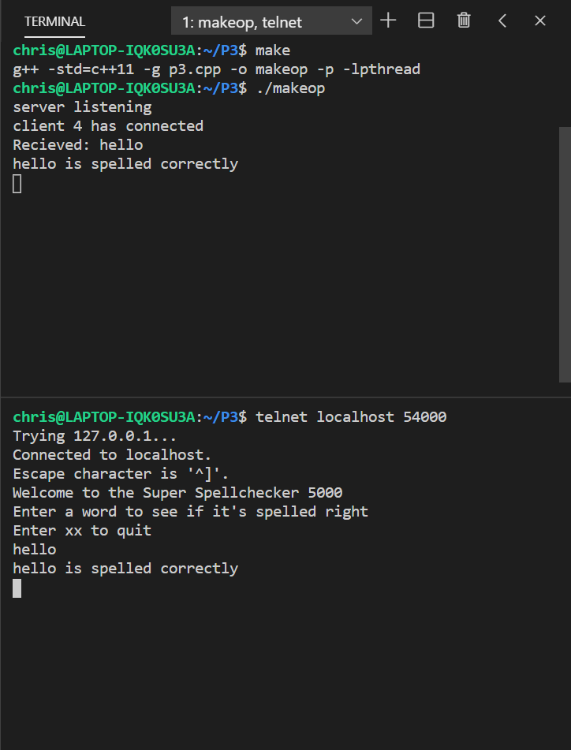

2) Thread Creation:

Each time a thread is created, up to a constant MAX_HANDLERS a statement is printed with the number of the thread indicated.

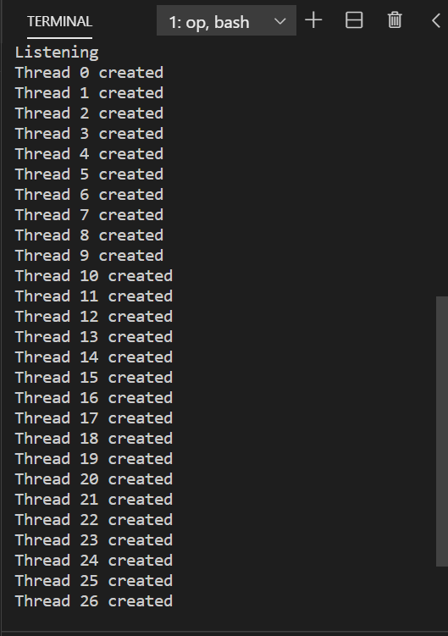

3) Modular Enqueue and Dequeue:

When trying to add an element to the queue that is already it its max capacity defined by a constant MAX_CLIENTS they will not be added to the queue.

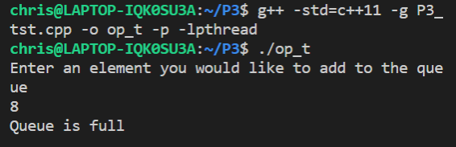

When trying to remove and element from the queue it returns false and prompts that the queue is empty

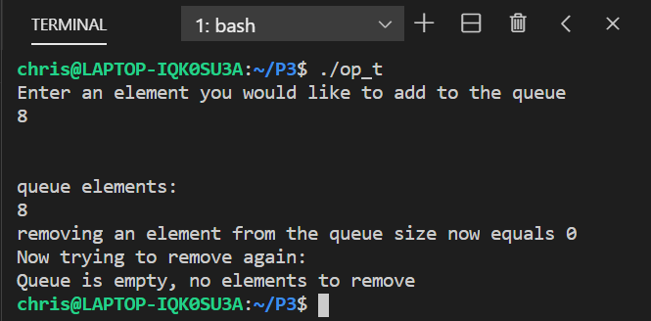

4) Modular test of spell checking:

The user enters what from the keyboard and the function returns true, when the user enters wat the function returns false because it is not in the dictionary file

